Test Scenario for the SEDL#8104 – The order should keep the source PAR?

Test Setup

Log in the PAR Workstation W903 with user id: JS/super
Run the following command to set up NBBO:

ar HybridTradeServer1 updateBOTR W_MAIN 204014288 B 1.00 ISE=50
ar HybridTradeServer1 updateBOTR W_MAIN 204014288 S 1.15 ISE=50

Test Case 1:
- Create a Simple Order and directly route it to PAR WorkStation W903.

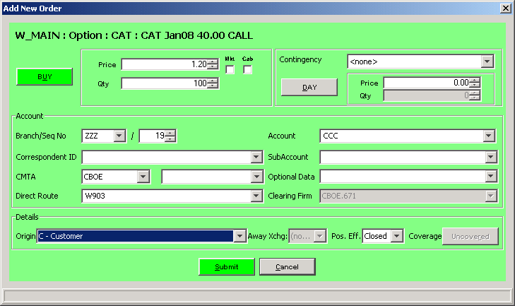

- From W903, select the order and click on the Book Bottom.

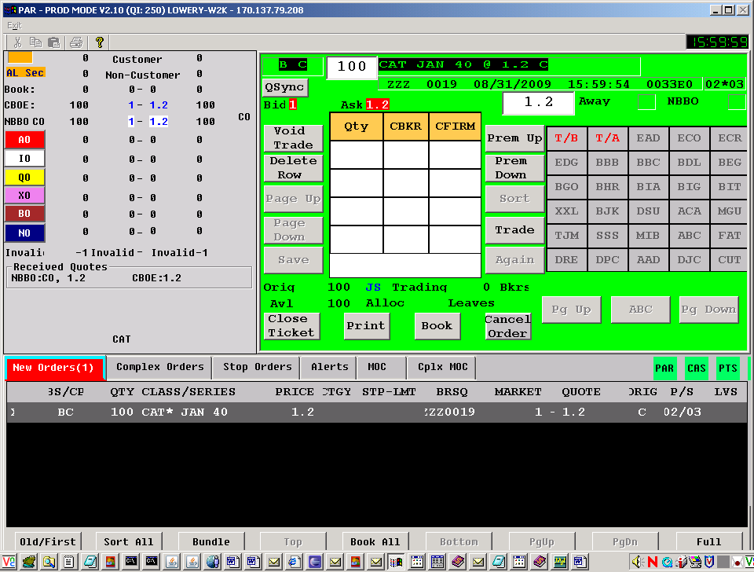

Verification:

From the Order Status Window below, you should see the order didn’t get filled.

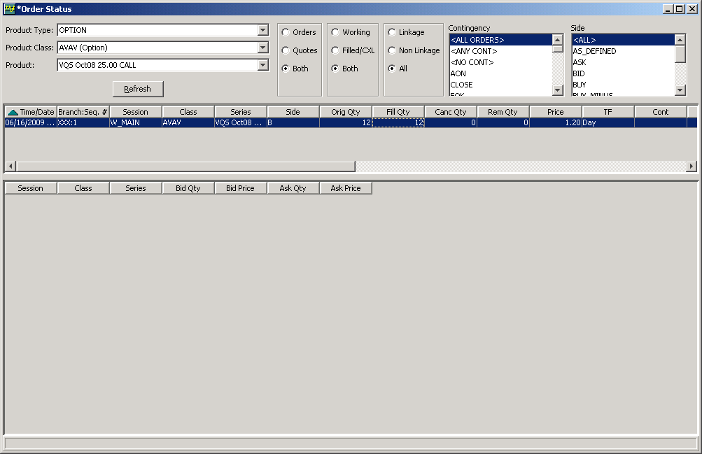

the oder should be returned back to W903 as follows:

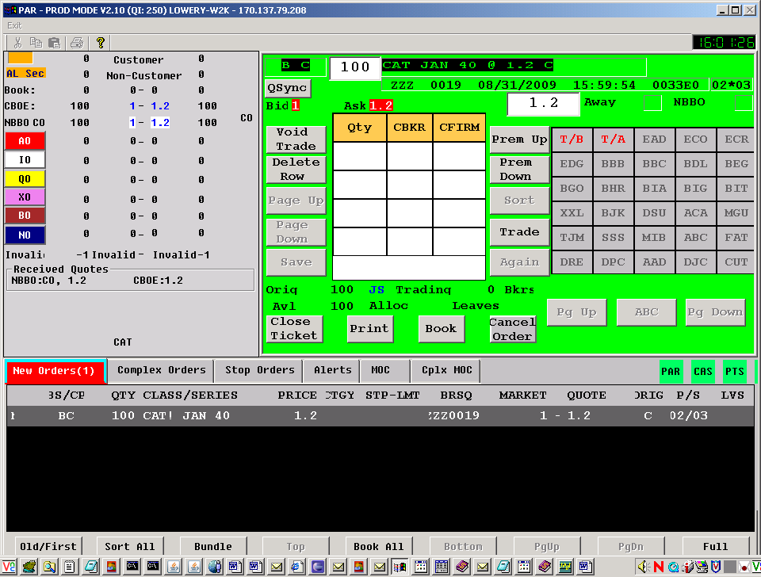

Test Scenario for the SEDL#8118 – PAR Issue, failed to print order

Test Setup

In the Routing Properties window, set the Booth Default Destination as B311.
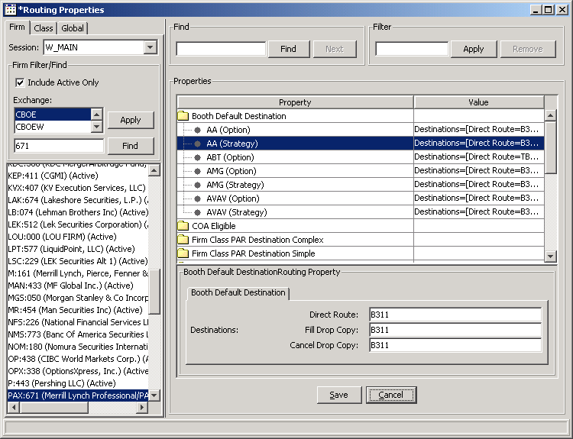

Test Case 1:

- Enter a Spread Order and directly route it to PAR WorkStation W904.
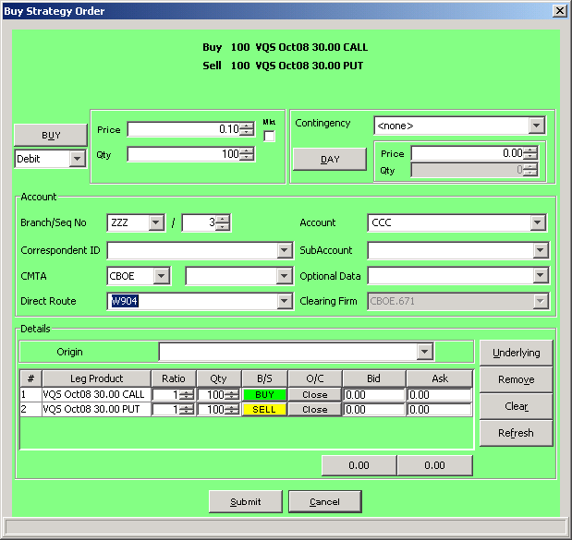

- Log on the BC box in your environment where your testing class is assigned to. Type the following AR command:

ar HybridTradeServer1 setException DVE PAR 1715

DVE: stands for DataValidationException
PAR: the Branch you use in your order
1715: The DataValidationException erro code that is for INVALID_CLEARING_FIRM

From the PAR workstation, click on the Print bottom, the order should be routed to the OMT.

Verification:

The order should get routed to the B311.

Test Scenario for the SEDL#8115 – COMPLEX ORDER ISSUE

Test Setup

- Log on the server box where your test environment is at, such as test13 (devenv4 with trade13/trade13)
- Run the following ar command

ar OHServerHybrid setStrategyRetryTime 20000

The ar command to tell the OHS to rest the Strategy Retyr Time to 20 seconds.

Rerun the following command to reset the time to 2 seconds, whenever you ‘re done with your test.

ar OHServerHybrid setStrategyRetryTime 2000

Test Case 1:

- Create a Complex Order and the order will be booked.
- Run the following command:

ar HybridTradeServer1 setException DVE PAR 1090

DVE – DataValidationException
PAR – the Branch you use in your test, PAR or AAA
1090 – Error Code, INVALID_PRODUCT

3. From the order status window, select the original complex order and enter a replacement order.

Verification:

- The original complex order (PAR:40) should get cancelled, the replacement order (PAR:41) shows as follows:

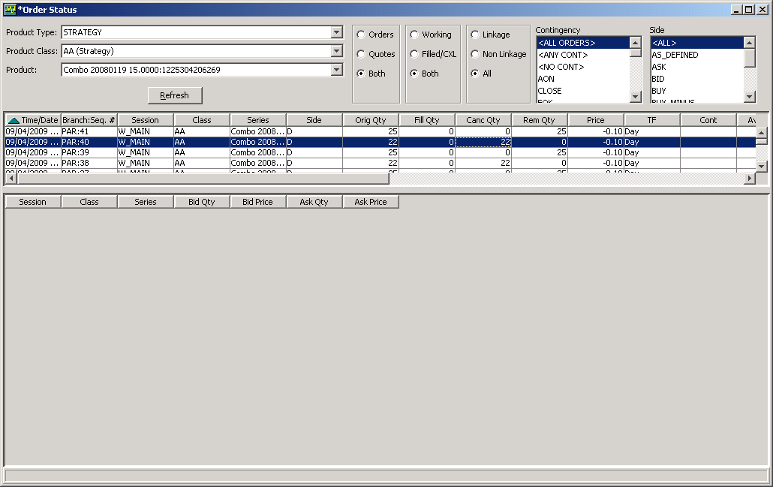

- Rerun the following ar command to remove the force exception:

ar HybridTradeServer1 setException "" "" 0

Test Scenario for the SEDL#7726 – OHS ISSUE

Test Setup

Test Case 1:

- Create a simple Order and the order will be booked.
- Run the following command:

ar HybridTradeServer1 setException DVE PAR 1701

DVE – DataValidationException
PAR – the Branch you use in your test, PAR or AAA
1701 – Error Code, INVALID_CONTINGENCY_VIX_SETTLEMENT

- Select the order from the Order Status Window, then right mouse click. Cancel replace the order.

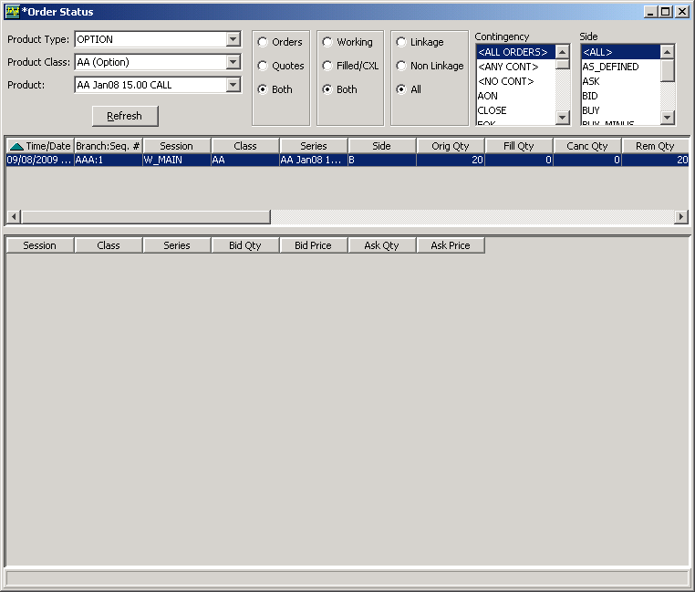

Verification:

. The Cancel Replace request should get rejected as follows:
